Te Kamaka
Submission by Patrick Nicholas

Te Kamaka (The Rock) is a framework upon which to build the future of Hato Petera.

The conception of the idea of a Te Kamaka was when the Bishop Pat visited Hato Petera College to announce the review and I suggested to him the need for Hato Petera to finds its rock to build its future. This resonated with the Bishop.

Te Kamaka is about fundamental differences to others or areas where Hato Petera wanted to be the best at. It is broken it into four pou with the Maori Catholic as the Pou Tokomanawa Kia Inoi Kia Mahi.
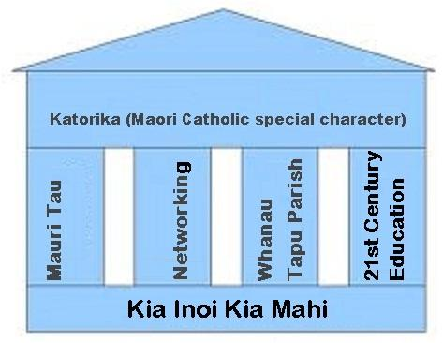

Te Kamaka is based on Jesus calling Saint Peter (Hato Petera), the Parable of the Man that built his house upon a rock and the importance of having a strong foundation.

Matthew 16:18:
I tell you that you are Peter, and on this rock I will build my church, and the gates of Hell will not overcome it. I will give you the keys of the kingdom of heaven; whatever you bind on earth will be bound in heaven, and whatever you loose on earth will be loosed in heaven".
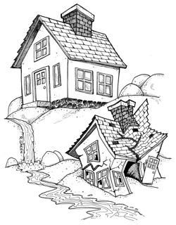
Matthew 7:24.
"Therefore whoever hears these sayings of Mine, and does them, I will liken him to a wise man who built his house on the rock:
25 "and the rain descended, the floods came, and the winds blew and beat on that house; and it did not fall, for it was founded on the rock.
26 "But everyone who hears these sayings of Mine, and does not do them, will be like a foolish man who built his house on the sand:
27 "and the rain descended, the floods came, and the winds blew and beat on that house; and it fell. And great was its fall."

Te Kamaka has four pou and the pou tokomanawa,

- Mauri Tau
- Networking
- Whanau Tapu Parish
- 21st Century Education
- The Katorika (special character) Kia inoi kia mahi (pou tokomanawa)
The quick sands are the hostel issues(being in Mauri Rere), short lease and the poor relationship with the Bishop.

Mauri Tau (1st pou)
‘The mauri of all Tauira will flourish when the environment is favourable.’ (Tangata ako ana i te kainga, i te Kareti, tau ana)
A Tauira in Mauri Rere has no structure in their life; they do not know whether they are Arthur of Martha. They do not know who they are or where they come from. They are easily stressed. They are like the man who built his house on the sand. When the rain came everything fell to pieces.

A Tauira in Mauri Tau has structure in their life; they know who they are, their whakapapa and Turangawaewae. They are calm. They are like the man that built his house on the rock. When the flood came, his house was secure.

The man that built his house on a rock. A rock is | The man that built his house on sand. Sand is
Clear Roles, boundaries, strong identity, and purpose. | Unclear and conflicting roles and boundaries and not knowing the purpose.
A person who knows their identity and is happy with who they are. | A person who is not sure of their identity and is insecure.
Importance of preschool and Yr 7 & 8 and a good start to primary and college | “An ounce of prevention is worth a pound of cure.”

The Tauira needs structure to their learning, to know the purpose, their role, benefits, relevance, boundaries and where they fit in the tribe and where their education fits in the Hato Petera College plan and opportunity to lead and give. Naku te rourou nau te rourou ka ora ai te iwi.

Mauri Tau can flourish when:
- When the Tauira know their whakapapa and whanau which gives structure to their lives and shows where they fit in.
- Tauira are taught Mythology, stories, histories and spirituality of their culture.
- Tauira have emotional competencies, when they can understand why they feel the way they do. They educate their heart and spirit and not just their brain.
- Problem solving abilities and other tools to combat stress.
- Physical exercise, Meditation, self-awareness and being in tune with nature, hauora and personal mauri.
- When whanau can self-determine their education
- When they have a positive mental attitude and self-image plus the ability to visualise their goals and their potential.
- Their culture, identity and knowledge are valued.

If our tauira wairua is strong, they wouldn't turn to negative things like alcohol abuse etc., and this would make for a healthier world.
For Mauri Tau, Tauira needs structure to their learning, to know the purpose, their role, benefits, relevance, boundaries and where they fit in the Kura and where their education fits in the tribal plan and opportunity to lead and give. Naku te rourou, nau te rourou, ka ora ai te iwi. Saint Peter was a man who had many Mauri Tau and Mauri Rere incidents.
Note: A lot of work has to be done to the hostel side before Mauri Tau can be achieved. Hato Petera College students are in an environment of quicksand where they are forever disrupted, interrupted and unsettled. Hato Petera College students should have their education and school life built on a rock.
Networking (2nd Pou)
Networking is working with other others such as AUT, businesses, Iwi Runanga, Maori in other Catholic colleges, Tauira Tawhito, Land Trusts, sponsors, scientists etc. The benefits would be in joint ventures, securing benefits for Tauira, sponsorships etc. It is about who you know not what you know.

I have used the word Networking as Saint Peter (Hato Petera) was a fisherman using nets.
According to the Gospel of Luke, on the day of this miracle, Jesus was preaching near the Lake of Genesaret (Sea of Galilee), when he saw two boats at the water's edge. Boarding the one belonging to Simon (Peter), and moving out a little from shore, he sat and taught the people from the boat. Afterwards, he said to Peter: "Put out into deep water, and let down the nets for a catch."
Peter answered “Master, we've worked hard all night and haven't caught anything. But because you say so, I will let down the nets."
When they had done so, "they caught such a large number of fish that their nets began to break," requiring help from another boat. When Peter saw the large catch, which filled both boats almost to sinking point, he fell at Jesus' knees and said, "Go away from me, Lord; I am a sinful man!" Jesus responded "Don't be afraid; from now on you will catch men," after which Peter and his partners James and John left everything and followed Jesus.
*Note
Communities of Learning are a limited form of networking. We require a communities that include other Maori and Catholic organisations as well as employers etc. Hato Petera academies are an excellent form of networking.
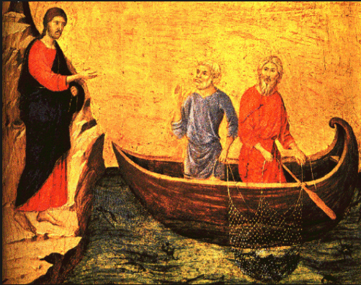

Whanau Tapu Parish (3rd pou)
This pou is about keeping the Parish and the relationship with the bishop strong.

This Pou is about building capacity. Hato Petera should look at developing their own order of catechists? A few years ago, Patrick Nicholas was working with Father Tony Brown to develop a new order of priests called Peterans, but when he became sick that plan folded.

We should renegotiate the integration agreement and the percentages remembering Saint Peter (Hato Petera) was a man who mixed with the gentiles. He was a link with people of different cultures.

Hato Petera College should also look at the Religious Education which is too general and develop a specific Catholic NCEA Curriculum.

The length of the lease is dependent on the relationship with the Bishop. Bad relationship bad lease, good relationship good lease. Saint Peter's relationship with Jesus was not perfect to start. He denied Jesus 3 times before the rooster crowed. But Saint Peter was able to later stand firm as a rock with his faith.

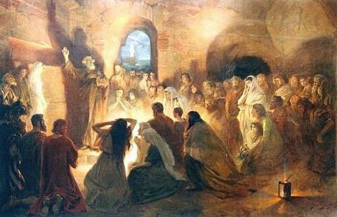
21st Century Education (4th Pou)
Saint Peter (Hato Petera) was a leader, he was always in front and so should Hato Petera College in the area of education. Saint Peter (Hato Petera) was creative and an innovator as he and others developed a completely new religious faith. He had to oversee financial, communication and implementation plans.

In the 21st Century, technology is moving very fast. In an every changing landscape, there is an opportunity to be the front runner and I believe that should be Hato Petera College.

Twenty-first century curriculum is interdisciplinary, holistic, project-based, culturally diverse, relevant and research-driven. It is connected to the local businesses and community groups. Students are self-directed, and work both independently and interdependently. The more linkages the better. The curriculum and instruction are designed to challenge all students and provides for diversity. The curriculum is not textbook-driven or piecemeal, but is thematic, project-based and integrated.

The Katorika (special character) Kia inoi kia mahi
(pou tokomanawa)

Te Kamaka supports the plans of the Hato Petera College BOT to differentiate and further develop their programs for the special character of Maori Catholic.

In the area of Maori:
- Te Rumaki Reo
- Teachers PD for teaching in Rumaki Reo (Year 7-8)

In the area of Catholic
- Development of Catholic curricullum and programs.

Recommendations
1/ That the Bishop and MOE support the concept of a “Te Kamaka,” (A rock to build the future of Hato Petera College), the concept of four pou and a pou tokomanawa.
2/ That the Bishop and MOE support the concept of Mauri Tau. Mauri Tau would be easier to implement accross the College Hostel if the option of the school holding the License for Boarding was implemented. There is some concern about the present situation where students are constantly being disrupted, interupted and unsettled, a condition similar to quicksand. Mauri Tau is the rock upon students at Hato Petera College can build their education.
3/ That the Bishop and MOE support the concept of Hato Petera College having the pou, Networking, Whanau Tapu Parish and 21st Century education and the pou tokomanawa ,the Maori Catholic Special Character.
4/ That the Bishop and MOE support the Hato Petera BOT strategies of the extension of the school to be Y7-Y13, and annual Recruiting and Marketing programmes

