Future Schooling Provision
Havelock North and surrounding area
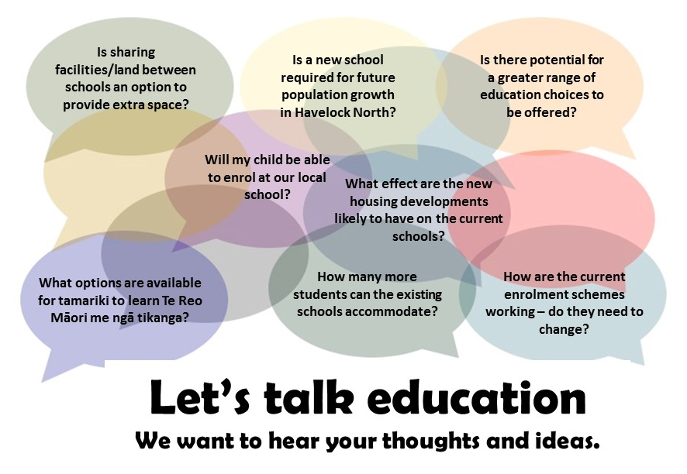

What are the great things about the education provision in your community as it currently sits?

Do you have any comments/concerns about education in your community?

What are some opportunities that you would like considered as part of the future strategy?

Any other comments or suggestions?

Thank you for your feedback
Please place in the feedback box or submit via email (HBArea.Strategy@education.govt.nz)

